WEEE, Battery and packaging waste management
Our responsibility:
The EU directives 2002/96 / EC and 2002/95 / EC made as mandatory the registration, collection and recycling of waste electrical and electronic equipment. The European Directive 94/62 / EC also mandated the recovery and recycling of packaging waste.

These guidelines were transposed differently in each EU country.

Our company complies with the laws of each country in the European Union, relating to waste management.
- Eco-participation: Our Company pay the eco-participation in public eco-organizations approved by the State, which supports the recycling of the devices, batteries and/or packaging.
- Communication: Our products and packaging are marked with symbols as "crossed bin" to encourage our users to bring them in an appropriate recovery structure.
- The Eco-design: Our Company designs its products so as to facilitate recycling. The Eco-design can prevent pollution from the beginning of the product life.

Your contribution:
This symbol on your telephone, the battery and the accessories means that these products must be taken to collection points at the end of their life:
- Municipal waste disposal centers with specific bins for these types of equipment
- Collection bins at points of sale.

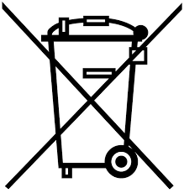

They will then be recycled, preventing substances being disposed of in the environment, so that their components can be reused.

In European Union countries: These collection points are accessible free of charge. All products with this sign must be brought to these collection points.
In non-European Union jurisdictions: Items of equipment with this symbol are not to be thrown into ordinary bins if your jurisdiction or your region has suitable recycling and collection facilities; instead they are to be taken to collection points for them to be recycled.

